How to create AKS cluster using Terraform | Create Kubernetes Cluster using Terraform | How to Create Azure Kubernetes Cluster using Terraform
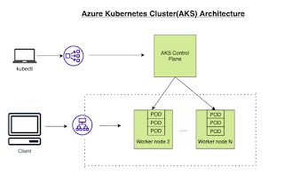
What is Azure Kubernetes Service (AKS)
Azure Kubernetes Service (AKS) is a managed container orchestration service, based on the open source Kubernetes system, which is available on the Microsoft Azure public cloud. AKS allows you to quickly deploy a production ready Kubernetes cluster in Azure, deploy and manage containerized applications more easily with a fully managed Kubernetes service. We will see how to create AKS cluster in Azure cloud using Terraform.
AKS cluster can be created by many ways as mentioned below:
1. Create AKS cluster in Azure portal directly
2. Create AKS cluster using Azure CLI
3. Create AKS cluster using Terraform.
Creating an AKS resource with Terraform is incredibly easy, it only requires a single resource azurerm_kubernetes_cluster and in this post, we are going to walk through the necessary steps to create this with Terraform. We will create ACR and create a role with ACRpull assignment as well
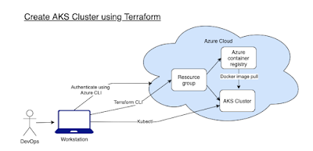
Pre-requisites:
- Terraform is installed on your machine.
- Azure subscription
- Kubectl is installed on your machine
- Azure cli is installed
Login to Azure using credentials
Make sure you are login to Azure portal first.
az login
Choose your Microsoft credentials.
Let's create following tf files using Visual studio Code:
1. Variables.tf - where we will define the variables used in main.tf
2. terraform.tfvars - Declare the values for the variables
3. providers.tf - declare the providers with version
4. main.tf - main configuration file with all the resources which will be created
5. output.tf - Export some data to output file

create providers.tf
provider "azurerm" {
features {}
}

terraform {
required_providers {
azurerm = {
source = "hashicorp/azurerm"
version = "3.62.1"
}
}
}
create variables.tf
variable "resource_group_name" {
type = string
description = "RG name in Azure"
}
variable "location" {
type = string
description = "Resources location in Azure"
}
variable "cluster_name" {
type = string
description = "AKS name in Azure"
}
variable "kubernetes_version" {
type = string
description = "Kubernetes version"
}
variable "system_node_count" {
type = number
description = "Number of AKS worker nodes"
}
variable "acr_name" {
type = string
description = "ACR name"
}

create terraform.tfvars
resource_group_name = "aks_tf_rg"
location = "CentralUS"
cluster_name = "my-aks-cluster"
kubernetes_version = "1.26.3"
system_node_count = 2
acr_name = "myacr321012"

create main.tf
#In Azure, all infrastructure elements such as virtual machines, storage, and our Kubernetes cluster need to be attached to a resource group.

resource "azurerm_resource_group" "aks-rg" {
name = var.resource_group_name
location = var.location
}

resource "azurerm_role_assignment" "role_acrpull" {
scope = azurerm_container_registry.acr.id
role_definition_name = "AcrPull"
principal_id = azurerm_kubernetes_cluster.aks.kubelet_identity.0.object_id
skip_service_principal_aad_check = true
}

resource "azurerm_container_registry" "acr" {
name = var.acr_name
resource_group_name = azurerm_resource_group.aks-rg.name
location = var.location
sku = "Standard"
admin_enabled = false
}

resource "azurerm_kubernetes_cluster" "aks" {
name = var.cluster_name
kubernetes_version = var.kubernetes_version
location = var.location
resource_group_name = azurerm_resource_group.aks-rg.name
dns_prefix = var.cluster_name

default_node_pool {
name = "system"
node_count = var.system_node_count
vm_size = "Standard_DS2_v2"
type = "VirtualMachineScaleSets"
zones = [1, 2, 3]
enable_auto_scaling = false
}

identity {
type = "SystemAssigned"
}

network_profile {
load_balancer_sku = "standard"
network_plugin = "kubenet"
}
}

create output.tf
output "aks_id" {
value = azurerm_kubernetes_cluster.aks.id
}

output "aks_fqdn" {
value = azurerm_kubernetes_cluster.aks.fqdn
}

output "aks_node_rg" {
value = azurerm_kubernetes_cluster.aks.node_resource_group
}

output "acr_id" {
value = azurerm_container_registry.acr.id
}

output "acr_login_server" {
value = azurerm_container_registry.acr.login_server
}

resource "local_file" "kubeconfig" {
depends_on = [azurerm_kubernetes_cluster.aks]
filename = "kubeconfig"
content = azurerm_kubernetes_cluster.aks.kube_config_raw
}

Run terraform commands

terraform init

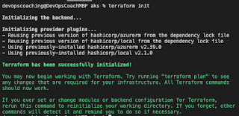

terraform validate

just to make sure syntax is right..

terraform plan
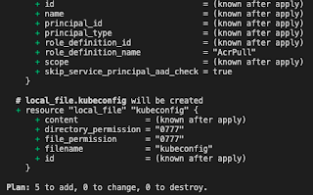

terraform apply

and type yes
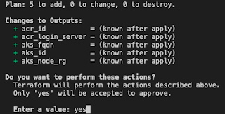

You will see following resources are created:

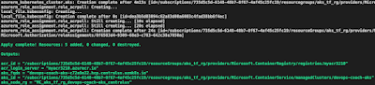

Move the generated Kubeconfig file to ~/.kube/config
mv kubeconfig ~/.kube/config

To verify if worker nodes are created, use the kubectl get nodes command to return a list of the cluster nodes.

kubectl get nodes

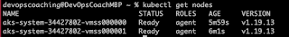
You will see worker nodes with health status ready.

Let's deploy some apps into AKS cluster.
Deploy Nginx App
kubectl create -f https://raw.githubusercontent.com/kubernetes/website/master/content/en/examples/controllers/nginx-deployment.yaml
Once the deployment is created, use kubectl to check on the deployments by running this command:
kubectl get deployments
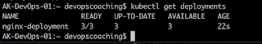

To see the list of pods
kubectl get pods
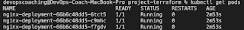

Perform cleanup by deleting the AKS cluster
To avoid Azure charges, you should clean up unneeded resources. When the cluster is no longer needed, use terraform destroy command to remove the resource group, AKS cluster service, and all related resources.
terraform destroy --auto-approve

